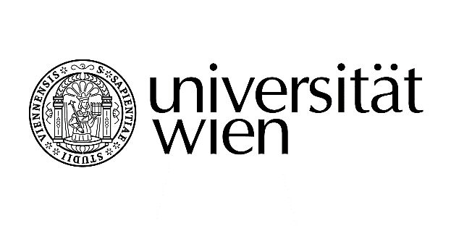
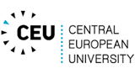
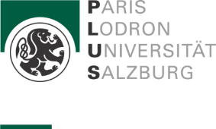

Vienna Lecture Series
on Comparative Constitutional Law & Theory
The Vienna Lecture Series on Comparative Constitutional Law & Theory aims to organise a high-level exchange on current and fundamental questions in constitutional law from an international, comparative, interdisciplinary or theoretical perspective. International scholars are invited to present their current research. The Lecture Series takes place four times a year at one of the participating universities.

The Vienna Lecture Series on Comparative Constitutional Law and Theory is organised by:
- Prof. Markus Böckenförde, Central European University
- Prof. Iris Eisenberger, University of Vienna
- Prof. András Jakab, University of Salzburg
- Prof. Konrad Lachmayer, Sigmund Freud University

